MEMORANDUM OF UNDERSTANDING
BETWEEN
MINT ARTISTS GUILD
and
ADD NONPROFIT NAME HERE ——
This Memorandum of Understanding (the “MOU”) is made effective as of …………….2026, by and among Mint Artists Guild (“Mint”), which operates at the Palmer Park Community House and several locations in Detroit, Mich., and _ _ _ _ _ _ _ _ _ _ _ _ _ _ _ (“Client”), whose address is _ _ _ _ _ _ _ _ _ _ _ _ _ _ _ _ _ _ _ _ _ _ _ _ _ _ _ _ _ _.
Background Information
- Mint is a Michigan non-profit that develops visual artists ages 13 to 24.
- Mint is planning a community building and generosity- enhancing campaign called Paint Detroit with Generosity (the “Campaign”). This campaign honors the work of local nonprofits and celebrates the creativity of our Detroit young artists.
- Many of the paintings will be distributed to a variety of nonprofit organizations and causes (known collectively as "Partners") including Client.
- This Memorandum contains the complete understanding and agreement between Mint and Client as it relates to the Campaign.
Agreement
The parties agree to the following:
- Client understands and agrees that this is not an exclusive agreement, and that many other nonprofits and charities are also expected to receive paintings.
- Once Client’s painting is delivered, Client may use, share, display, sell, auction or otherwise dispose of its painting at its discretion.
- In exchange for Mint’s promise to deliver one original painting to the Client (created by Mint youth artists), Client agrees that it will:
- share one social media post about Mint Artists Guild before June 30, 2027 on Facebook, Instagram or another social media site.
- share a photo or digital image of the completed photo on social media or in your organization’s newsletter, crediting Mint Artists Guild, before May 1, 2027
- authorize Mint to use Client’s logo and name in promoting the Campaign and its overall summer creative jobs program, where the Paint Detroit with Generosity paintings are created.
- Client only has the right to possess and dispose of the original painting as it sees fit. The created image may not be photocopied, reproduced, or used by Client, in print, online or otherwise, without permission of Mint Artists Guild, except as a means of sharing the partnership or some of Mint's story. Mint retains the copyright and all rights to use the image as it sees fit in any medium.
- Mint agrees that the painting will be completed and available as soon as practical and that Client’s painting will be available for pickup no later than March 30, 2027
- Client agrees that should the painting be on display or shared through social media or other media, it will be identified as a product of Mint using the term "© 2026 Mint Artists Guild".
- The undersigned each certify that he or she is a duly authorized officer of the entity for whom he or she is executing this MOU and, as such, is authorized to execute and oblige and observe all terms of this MOU.
- This MOU is effective as the date shown above and shall remain in effect until the painting is delivered to Client, except that Paragraphs 5 and 6 survive any expiration or termination of this MOU.
- This MOU shall be governed by the laws of the State of Michigan.
- Nothing contained in this MOU shall create or be deemed to create a partnership between Mint and Client, or to make any party the agent or representative of the other parties for any purpose whatsoever.
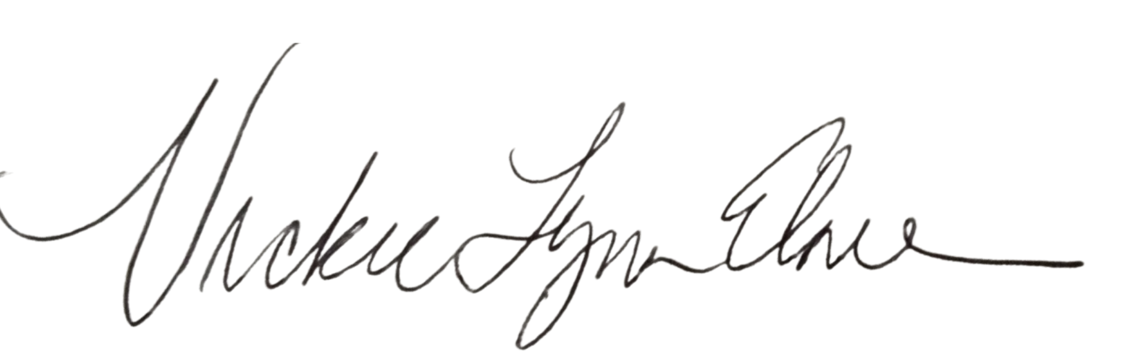
MINT ARTISTS GUILD

By: Vickie Elmer, Executive Director By:
Date: April 7, 2026 Date: ________________________

Send any correspondence to:
Mint Artists Guild NONPROFIT NAME
PO Box 21667
Detroit, MI 48221 Detroit, MI

